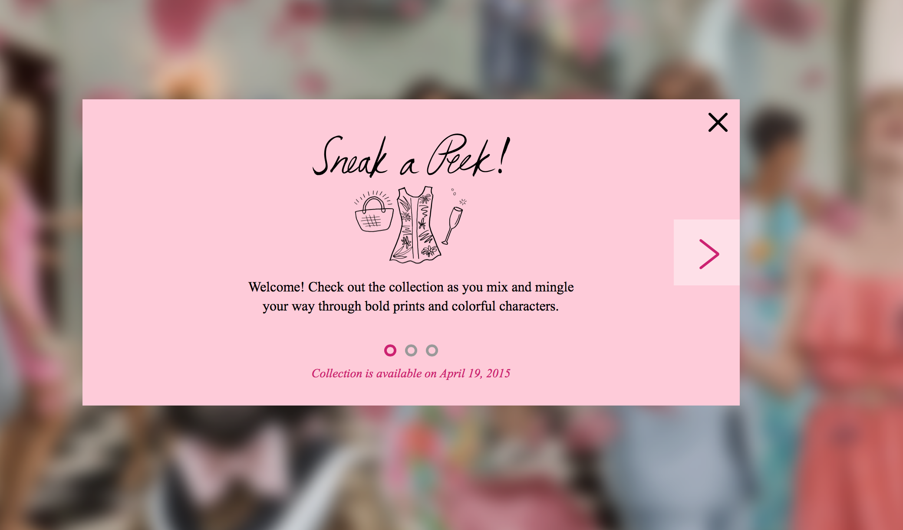

<http://lilly.olson.com>

This is an absolutely beautiful website! This is how the page opens up. CTA slide show right at the beginning. A unique font style is used to draw you in to take a look. The close buttons all have an animation to them. You are able to scroll through three slides to pick where you want to start out. A slight hint at what is to come is shown in the blurry background, which temps you in further.

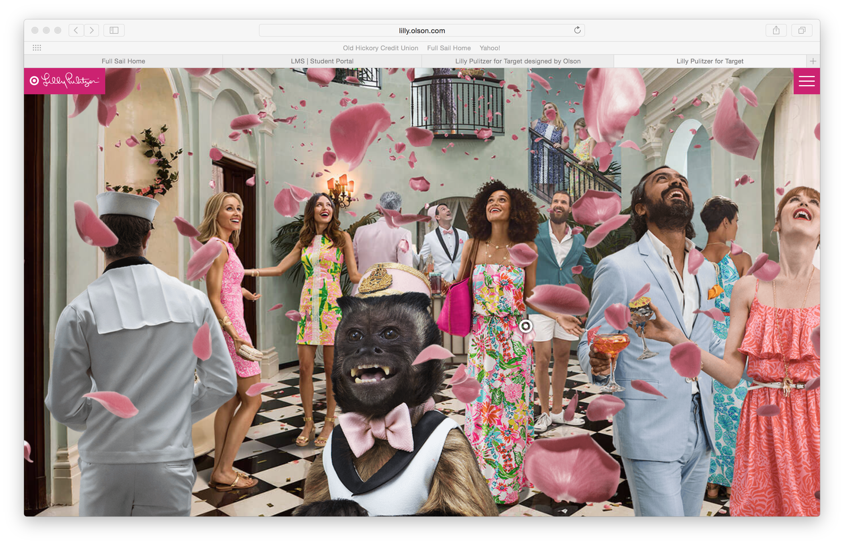

After you click the “X” close button, this is the scene. No text, no menus, total interaction. Just as exciting as you pictured from the first blurry hint. This whole page is interactive. Mouseover functions enable the monkey to smile, the umbrella

to open and close, a girl’s hair to “flip up”, etc. The page is set up to be one continuous shot of a party that you scroll through with your mouse. There are small “target” icons place throughout the scene. When these icons are clicked…

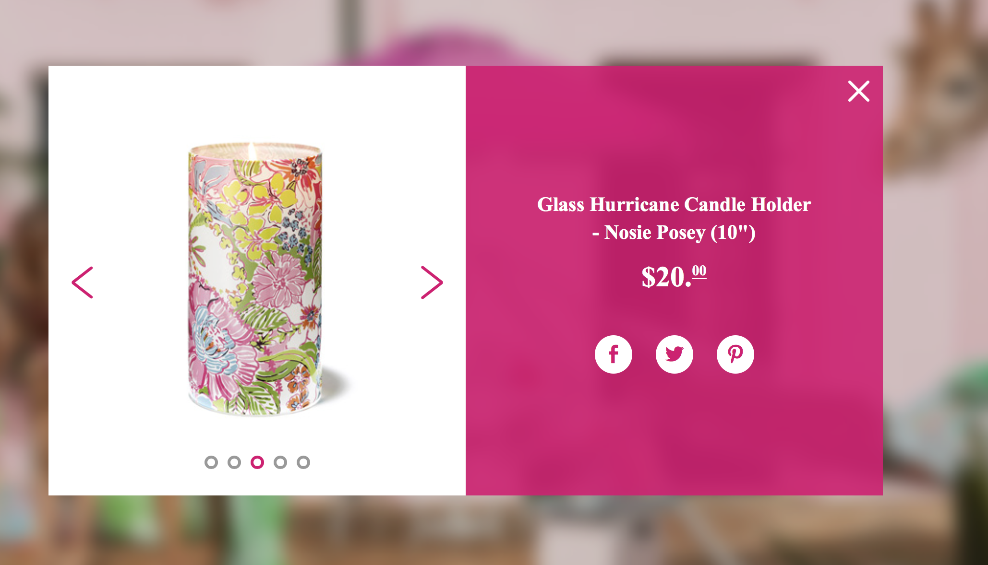

…a modal pops up that lets you scroll through the items featured in that targeted area. It could the table and dinnerware, (as shown above), or the women’s dress and accessories.

A side menu is available to go directly to the target website for purchasing any of the items showcased. You are able to share via social media anything on this site.

This is one of the most exciting and interactive sites I have ever seen.

